**PHY 621 Electrostatic Charge and Electrostatic Force**

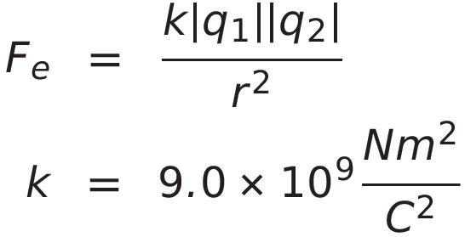

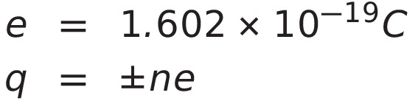

1. Copper has 29 protons in the nucleus. What is the total charge of the nucleus?

1. A neutral copper atom has 29 electrons orbiting the nucleus. What is the total charge of the orbiting electrons?

3. An ebonite rod gains a negative electrostatic charge of 4.936 x 10 5 C when it is rubbed with fur. How many electrons did the rod gain?

4. An acrylic rod loses 1583 electrons when it is rubbed with wool. What is the total charge gained by the rod? (Hint, what electrical particle is not paired causing this charge?)

5. A neutral oxygen atom has 8 protons in the nucleus. The atom has 6 valence electrons. Assume that they orbit at an average distance of 5.88 x 10  10 m from the nucleus.

a) What is the total charge of the nucleus?

b) Focus on one valence electron, ignoring all other electrons in the atom. What is

the size and direction of the electrostatic force of attraction acting between this

valence electron and the nucleus?

6. A 3.89 x 10 -11 C charge is placed an unknown distance from a 6.87 x 10 - 9 C charge. They experience an **attractive** force of 6.82 x 10 -4 N. What is the distance separating these two charges?

7. Refer back to question #6.

a) How many protons are needed to make a charge of 3.89 x 10 -11 C ?

b) How many electrons are needed to make a charge of - 6.87 x 10 - 9 C?

8. Two like point charges are placed 135.8 cm apart.

They experience a **repulsive force** of 2.84 x 10 -6 N. What is the size and possible electrostatic charge of each point charge?

**Answers**:

1. 4.65 x 10 -18 C 6. 1.9 x 10 -3 m

2. -4.65 x 10 18 C 7. a) 2.43 x 10 8 p+

3. 3.08 x 10 14 elec. b) 4.29 x 10 10 e

4. 2.54 x 10 -16 C 8. +/- 2.4 x 10 8 C

5. a) 1.28 x 10 -18 C

b) 5.3 x 10 -9 N[ towards]